**EXPERIMENT -2**

**EXP NO 2:** CREATE A SIMPLE CLOUD SOFTWARE APPLICATION FOR FLIGHT RESERVATION SYSTEM USING ANY CLOUD SERVICE PROVIDER TO DEMONSTRATE SAAS.

**DATE: 27/09/25**

**AIM:** To create a simple cloud software application for flight reservation system using any cloud service provider to demonstrate (saas).

**PROCEDURE:**

Step1: Go To Zoho.Com.

Step 2: Log Into the Zoho.Com.

Step 3: Select One Application Step.

Step4: Enter Application Name as Flight Reservation System.

Step 5: Created New Application Flight Reservation System.

Step 6: Select One Form

Step 7: The Software Has Been Created.

Form 1: Passenger details.

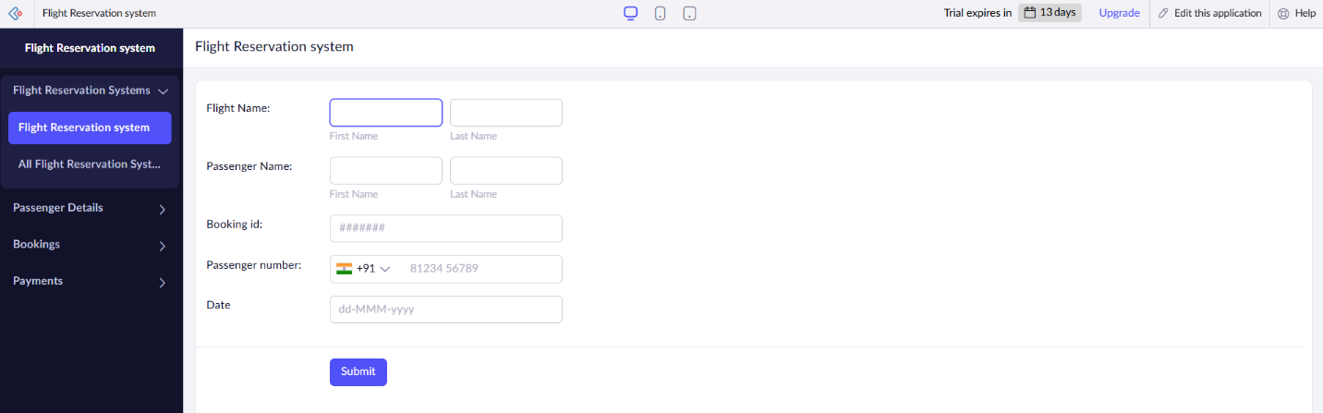

Form 2: Booking

Form 3: Payment

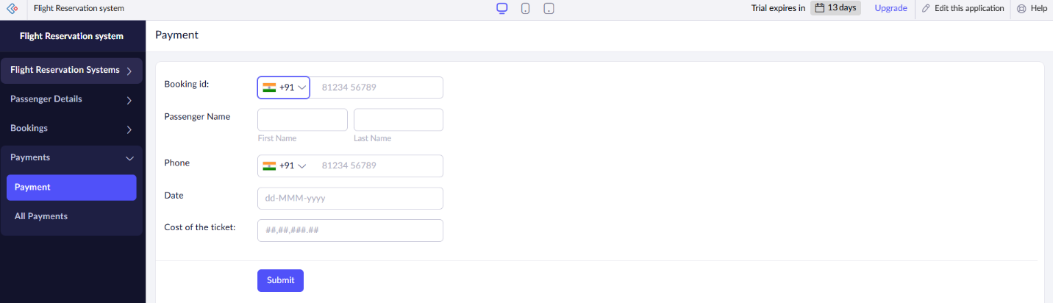

Form 1: Passenger details.

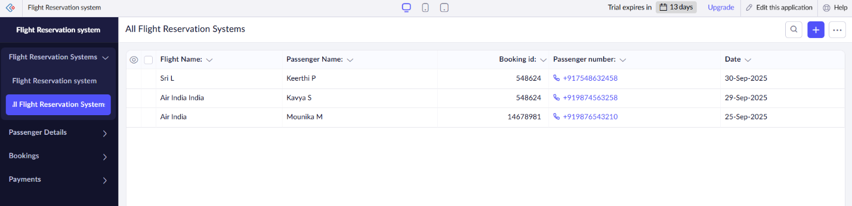

Form 2: Booking

Form 3: Payment

Result: A working web application where **multiple airlines (tenants)** can sign up, configure their flights, and passengers can search, book, cancel flights via the web UI — all hosted in the cloud, with usage-based billing and autoscaling.